MusT BE DISPLAY
SCARECROWS ED
4 m on Monday 6th May
on Saturday 4th until

R

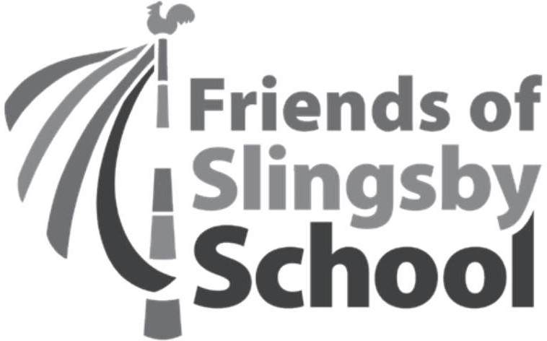
Villnęe
SCARECROW TRAIL

our name:
our address:
hone number:
mail address:
anne of the Scarecrow to be entered:
lease suggest a clue for children to guess the name of your Scarecrow:
here will the Scarecrow be positioned or do you need an allocated place?
TO ENTER
Entries are £z each and can be handed into Slingsby School. Please include your £2 entry fee with your completed form. Or enter by email including your name and all the items listed in the entry form to: friendsofslingsbyschool‹a›hotmail.co.uk. Please pay your ez entry fee direct to the Slingsby CP PTA account, including your surname in the reference. Sort code: os 05 70, Account No: 35422341.
ENTRIES FROM OUTSIDE THE VILLAGE ARE WELCOME. IF YOU LIVE OUTSIDE THE VILLAGE YOU WILL BE ASSIGNED A POSITION TO SET UP YOUR SCARECROW.

